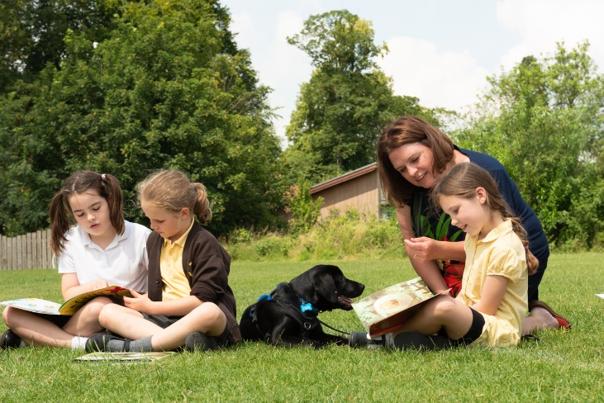
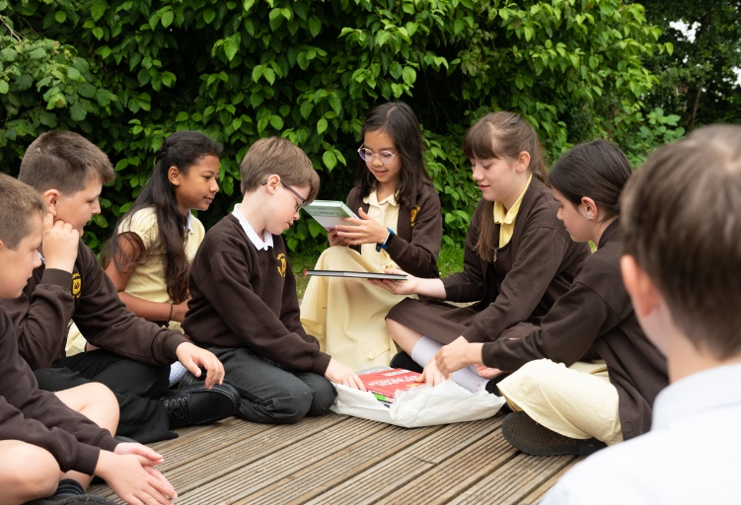


Volunteering at Dunalley
Information and application form


Welcome
Thank you for your interest in volunteering at Dunalley Primary School.
We hope that the information in this pack provides you with the information and detail to assist you in your application and, more importantly, help to develop your understanding of what it means to volunteer at Dunalley Primary School, a supportive, vibrant and successful primary school nestled in the beautiful Cotswold spa town of Cheltenham.
Our vision is to be the school that empowers all children to embrace learning, achieve their personal best and build their emotional, social and physical wellbeing.
- We value each individual and celebrate diversity
- We care about each other and the environment
- We persevere and grow together
- We are ready, respectful and safe
Our goal is to equip our children with the knowledge, understanding, skills and attitudes that will enable them to thrive in our ever-changing world.

The Role of volunteer at Dunalley
Being a volunteer within a school setting is a very rewarding role. One where you can become a positive role model for children, it can also provide a sense of purpose and a sense of community.
We fully understand and appreciate the pivotal role our volunteers play in the creation of our stimulating learning environment and the development of our pupils.

At Dunalley there are several ways to help. You may be asked to work supporting our Outdoor Play and Learning (OPAL) initiative, help at lunch times or work with individuals and/or small groups of children, helping with their learning.
Our pupils are ambitious, independent, inquisitive and love to challenge themselves. At Dunalley all members of our school community are proud of our values; our staff deliver the highest quality in teaching and pastoral care for our children and support for their families. We all work hard to achieve our shared goal of learning and achieving together through collaboration and teamwork in an inclusive environment.
Information for applicants
The details on this application form will help the school decide your suitability for working with our pupils, their health, safety and wellbeing is absolutely our main concern, so we will take all necessary precautions to protect them.

Data Protection
In accordance with our obligations under the Data Protection Act 2018. The information you disclose in this application form will not be kept for any longer than its purpose or be shared with any other organisation unless required by law.

Equal Opportunities
The school appreciates and promotes diversity in our workforce – we aim to ensure that people from all backgrounds can work at the school, to ensure our pupils leave school with a well-rounded view of the community and the people within it. The school encourages all people to volunteer with us and will review applications from any person, regardless of the following characteristics:
Age, Disability, Race, Gender, Religion or belief, Sex, Sexual orientation, Relationship status, Pregnancy
Attendance
It is important that a volunteer is reliable and comes to school on the agreed days and times. If you are unable to come for any reason, please can you ring the school office on 01242 512391 as early as possible.

Appearance and conduct in School
Volunteers must ensure appropriate clothing is always worn. This should reflect the professional nature of the job as well as ensuring dignity and decency are maintained. Clothing including tattoos, piercings and jewellery should not be offensive, intimidating or lead to anyone, particularly pupils’, distress or discomfort.

Our School Vision and Values
Learning and achieving together
Our school empowers all children to embrace learning, achieve their personal best and build their emotional, social and physical wellbeing.
· We value each individual and celebrate diversity
· We care about each other and the environment
· We persevere and grow together
· We are ready, respectful and safe
Our goal is to equip our children with the knowledge, understanding, skills and attitudes that will enable them to thrive in our ever-changing world.
Confidentiality
At Dunalley Primary School we welcome our volunteers who extend and enrich opportunities for our children. It is vital that school matters are not discussed outside school. Volunteers should not discuss individual children with anyone outside school. If parents raise discussion concerning school issues with volunteers it is essential that volunteers politely refer the enquiry directly to the class teacher or a member of the Senior Leadership Team. Confidentiality is crucial and must be adhered to.

Mobile Phones
Mobile phones should be switched off in school and only turned on at break times or lunchtimes in an area where there are no children.

Our commitment to Safeguarding
Dunalley Primary School is absolutely committed to safeguarding and promoting the welfare of children and young people/vulnerable adults and expect all staff and volunteers to share this commitment.
The governors and staff of Dunalley Primary School fully recognise the responsibility it has to the safeguarding and protection of pupils.
All volunteers will receive comprehensive safeguarding training as part of their induction.

All governors and staff, including volunteers, have a full and active part to play in protecting children and young people from harm.

All volunteers are subject to a criminal record check from the Disclosure and Barring Service which will require you to disclose details of all unspent and unfiltered spent reprimands, formal warnings, cautions and convictions in your application form.

Please review the school’s website for Safeguarding and Child Protection policies here.

One to One Situations
- If you are working with a child or group of children, ensure the class teacher knows where you will be working.
- When working with a child try to ensure that the location is visible to others - corridors or rooms with the door open.
- Avoid meetings with a child in remote or secluded areas.
- Avoid physical touch
- Be aware that even well-intentioned physical contact may be misconstrued by the child, an observer or by anyone to whom this action is described
- When physical contact is made with pupils this should be in response to their needs at the time, of limited duration and appropriate to their age, stage of development, gender, ethnicity and background. Appropriate physical contact in schools will occur most often with younger pupils.

What to do if a child discloses abuse
- Stay calm and reassuring
- Do not make any promises to the child - the situation may cause you to react emotionally
- Listen and reassure
- Do not press for details
- Tell the child that they were right to tell
- Immediately contact the child’s class teacher and report your conversation.
- The schools designated safe guarding leads are:
- Mrs A Godfrey
- Mr P Duroe-Richards
- Miss A. Vine
- Mr N.Jones
If you have any doubts please speak to one of them.

Whistle blowing
- Reasons for whistle-blowing – Don’t think ‘what if I’m wrong?’ – Think ‘what if I’m right?’
- Everyone has a responsibility for raising concerns about unacceptable practice or behaviour.
- To prevent the problem worsening or widening.
- To protect or reduce risks to others.
- To prevent becoming implicated yourself.

Report any behaviour by adults in the school that raises concern regardless of source to the Head Teacher, if your concern regards them, report to the Chair of Governors.

Fire and Emergency Evacuation Procedures
Volunteers should ensure that they are familiar with the school procedures and act upon the requirements.
There are evacuation information posters in each room.
The Fire Information for Staff and volunteers is available from the school office, if you have any queries or concern please discuss them with the member of staff you are working with, the Site Manger or School Business Manager.

Application to volunteer
Personal details
Name:
Previous name:
Telephone number (home):
Telephone number (mobile):
Email address:
Role applied for:
Address line one:
Address line two:
Town:
Postcode:

Relevant employment/volunteering history
Start date | End date | Position held | Type of role (full-time, part-time, voluntary) | Reason for leaving | Reference available?  ✓ ✗
dd/mm/yyyy | dd/mm/yyyy | Activities coordinator | Voluntary | Term of service ended | ✓
Relevant training and education
Start date | End date | Name of provider | Subject | Level | Grade | Date awarded
dd/mm/yyyy | dd/mm/yyyy | Secondary school | PE | GCSE | B | dd/mm/yyyy

References
All volunteer applicants must give two recent and relevant references – the first of which must be from your current or most recent employer or organisation you volunteered for. Please ensure all the contact details you have specified are correct and inform the referees you select that the school will contact them. The address information the school requires relates to the referee’s work address, where applicable.
Referee one
Name of referee:
Relationship to candidate:
Telephone number (work):
Email address:
Address line one:
Address line two:
Town:
Postcode:

Referee two
Name of referee:
Relationship to candidate:
Telephone number (work):
Email address:
Address line one:
Address line two:
Town:
Postcode:

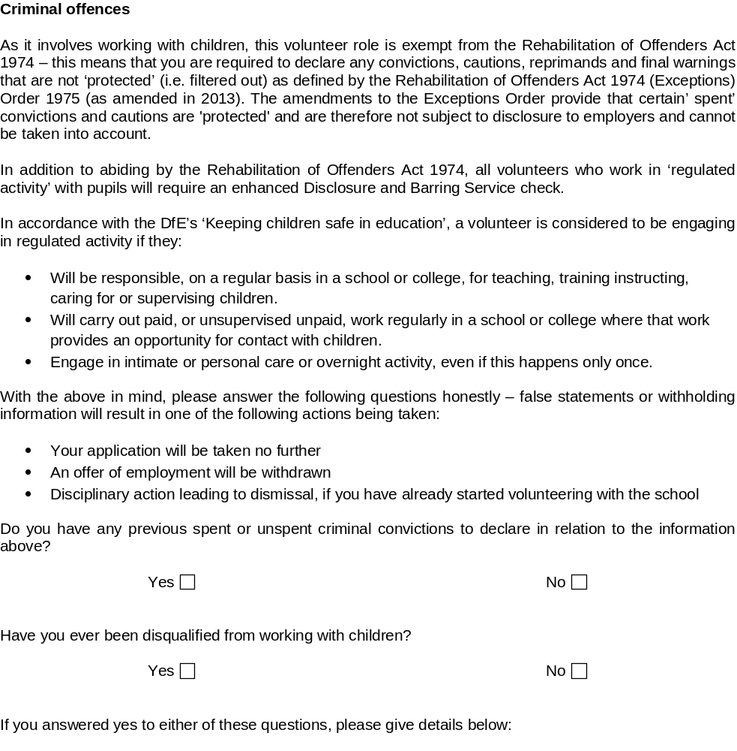

Supporting statement

Please include any skills or experience that you bring to the role, explain your motivations for wanting to work with children or young people and outline what you want to achieve from volunteering.
Volunteering across multiple settings – Please let us know if you volunteer in other settings.

Declaration

By signing this form, I declare that the information given on this form is correct to the best of my knowledge and belief, and I understand that any false statements on this form could result in my application for a volunteer role being rejected or terminated.
I agree that the information I give you in connection with this application may be stored and processed for personnel management.
Signed:
Date:

